**Copy code repos to local machine:**

1. Navigate to the GitHub repos
2. Click the dropdown arrow next to the “Code” button
   1. 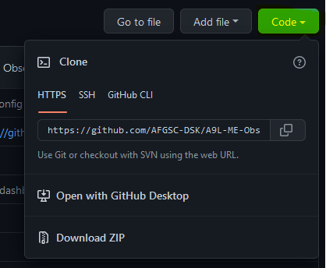
3. Confirm “HTTPS” is selected with an orange underline. Then click the icon with files on it to the far right.
   1. Expected Result: The icon will change to a green checkmark with a dialogue stating “Copied!”
   2. 
4. Go to Visual Studio Code and open a new command prompt within it.
5. Type in the command “git clone <repos_url>” where the <repos_url> is the HTTPS url copied at the end of step 3).
   1. Expected Result: 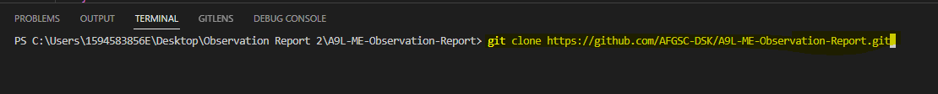
6. Press enter.
7. Confirm new code repository is now copied to location by clicking File -> Open Folder -> <project_repos_name>.